Title : Comparative Performance Evaluation of TF-IDF and Okapi BM25 Ranking for Enron E-mail Search
Students Name | Registration No. | Email-id
Tanay Anand | 23FE10CSE00476 | tanayanand911@gmail.com
Priyanshu Paul | 23FE10CSE00780 | priyanshu.paul003@gmail.com
Jiya Tejwani | 23FE10CSE00013 | tejwanijiya05@gmail.com
Under the supervision of Prof. Shweta Sharma

Abstract — Lexical ranking functions remain the backbone of practical search systems. This project builds a complete search engine over the Enron e-mail corpus (517,401 raw messages, 251,115 after de-duplication) and compares two classical ranking models implemented by us: TF-IDF with cosine similarity and Okapi BM25. Sparse CSR/CSC matrices shrink a 158-billion-cell term–document matrix from about 1.27 TB to 300 MB, and a Flask interface shows both rankings side by side. Because Enron has no relevance labels, the project’s own ranking functions are also evaluated on the Cranfield test collection against seven reference rankers. BM25 obtains the best nDCG@10 among lexical and probabilistic models (0.363 against 0.349 for TF-IDF), wins on 105 of 225 queries against 77, and is 1.5× faster; length normalisation accounts for most of its gain. On real e-mail, TF-IDF favours one- to ten-word replies while BM25 surfaces informative messages, at about 5 ms per query. Published BEIR and MS MARCO results confirm that BM25 remains competitive with neural retrievers when no in-domain training data is available.
Keywords: Information Retrieval · TF-IDF · Okapi BM25 · Inverted Index · Enron E-mail Corpus · Cranfield Dataset
1. Introduction
Information Retrieval (IR) is the problem of finding, in a large collection of documents, the few that best answer a user’s query, and showing them in a useful order. It sits behind web search, enterprise and e-mail search, legal e-discovery, and the retrieval step of Retrieval-Augmented Generation (RAG) systems. Whatever the application, the central question is the same: given a query, how should every document be scored so that the most relevant ones appear first?
The classical answer is lexical matching. Each document is reduced to the words it contains, an inverted index records which documents contain which words, and a ranking function turns word statistics into a score. Two ranking functions dominate this family. TF-IDF with cosine similarity, from the vector space model of the 1970s [1, 2], weights a word by how often it appears in a document and how rare it is in the collection. Okapi BM25, developed from the probabilistic relevance framework and refined at TREC in the 1990s [3, 4], keeps the same intuition but adds term-frequency saturation and a tunable document-length normalisation. BM25 is still the default ranking function of Lucene, Elasticsearch, OpenSearch and Solr.
TF-IDF has two known weaknesses. Its weight grows linearly with term frequency, so a document that simply repeats a query word can outrank a genuinely informative one, and its cosine normalisation divides by the full length of the document vector, which strongly favours very short documents. Both weaknesses matter for e-mail, where messages range from one-line replies to multi-page reports. Neural retrievers based on transformers capture meaning and synonyms, but they need trained models, GPUs and large vector indexes, and published benchmarks show that they often lose to BM25 on domains they were not trained on.
In this project we built a complete search engine for the Enron e-mail corpus, a real collection of 517,401 corporate e-mails, and used it to compare TF-IDF and BM25. Our contributions are:
- Search engine: a parsing, de-duplication and indexing pipeline over 251,115 unique e-mails, with a Flask web interface that shows TF-IDF and BM25 results side by side.
- Implementation: TF-IDF through scikit-learn and BM25 written from scratch in about fifteen lines of NumPy over a SciPy sparse inverted index.
- Benchmark: an evaluation of the project’s own ranking functions, unchanged, against seven other rankers on the Cranfield test collection, with a BM25 parameter sweep and a per-query significance test.
- Positioning: a comparison of our findings with published zero-shot (BEIR) and in-domain (MS MARCO) results for neural retrievers, including their latency and index-size costs.
2. About Dataset
2.1 Visualization of dataset in form of graphs or tables and explanation of dataset using an example
Enron e-mail corpus. Enron, a large US energy company, collapsed in 2001 after an accounting fraud. During the investigation the US Federal Energy Regulatory Commission (FERC) made the e-mail of about 150 employees public. The corpus is the largest public collection of real corporate e-mail and is widely used for search, NLP and spam research [10]. We use the Kaggle release, a single 1.4 GB file, emails.csv, with one row per message (columns file and message). Table 1 summarises the collection and Figure 2 (left) shows the effect of de-duplication: Enron’s mail system stored the same message in several folders (sent, _sent_mail, all_documents), so roughly half of the rows are exact copies.
Table 1. Statistics of the two collections used in this project.
Property | Enron e-mail (search engine) | Cranfield (evaluation)
Documents | 517,401 raw → 251,115 unique e-mails | 1,400 aeronautics abstracts
Queries | free-text user queries (no labels) | 225 natural-language queries
Relevance judgements | none | 1,612 human judgements
Vocabulary | 631,253 unique terms | 7,185 unique terms
Average length | 97 distinct terms per e-mail | 88 terms per abstract
Size | 1.4 GB CSV · 1.1 GB index | 1.7 MB XML

Example. A raw row of emails.csv contains the folder path and the full message with headers:
file: allen-p/_sent_mail/1.
message: Message-ID: <18782981.1075855378110.JavaMail.evans@thyme>
Date: Mon, 14 May 2001 16:39:00 -0700 (PDT)
From: phillip.allen@enron.com
To: tim.belden@enron.com
Subject:
Here is our forecast
Python’s email module turns this into the record {from: phillip.allen@enron.com, to: tim.belden@enron.com, date: …, subject: “”, body: “Here is our forecast”}. The subject and body are concatenated and tokenised, so that the e-mail “Gas prices rising in California” becomes the terms [gas, prices, rising, california].
Cranfield test collection. Because Enron has no relevance labels, ranking quality cannot be measured on it directly. We therefore also use Cranfield, the classic IR test collection from the 1960s [9]: 1,400 abstracts of aeronautics papers, 225 queries and human relevance judgements. A typical query is “what similarity laws must be obeyed when constructing aeroelastic models of heated high speed aircraft”. Figure 2 (right) shows that Cranfield abstracts are fairly uniform in length (median 78 terms), which, as Section 4 shows, limits how much BM25’s length normalisation can help on this collection.
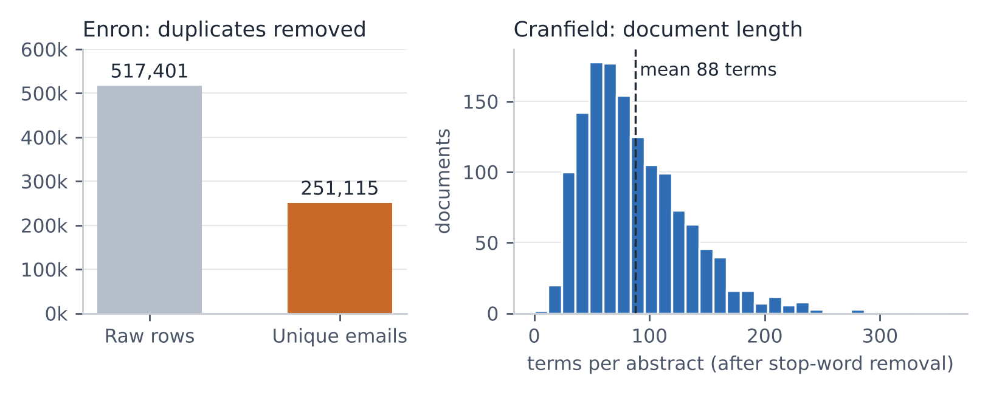
Figure 2: Left, Enron rows before and after removing exact duplicates. Right, length distribution of Cranfield abstracts.
3. Methodology
The system has two phases. Indexing runs once, offline, and takes about 75 seconds on the full corpus. Searching runs on every query and takes a few milliseconds. Both ranking functions are applied to the same tokenised text, so any difference in their results comes from the ranking formula alone. The complete workflow is shown in Figure 1.
[ emails.csv · 517,401 rows ]
│ csv.DictReader
▼
[ Parse (email module) → De-duplicate (from, subject, body) ]
│ 251,115 unique e-mails
▼
[ Tokenise: lowercase · split · remove stop words ]
┌──────────────┴──────────────┐
▼ ▼
[ TfidfVectorizer ] [ CountVectorizer ]
CSR matrix of CSC matrix of counts
L2-normalised weights + document lengths
└──────────────┬──────────────┘
▼
[ pickle → index.pkl (1.1 GB), loaded once in 1.3 s ]
│
▼
[ Query → search_tfidf() | search_bm25() → rank() → top 10 ]
│
▼
[ Flask page: TF-IDF and BM25 columns, query terms highlighted ]
Figure 1: Architecture of the Enron e-mail search engine, from raw CSV to side-by-side ranked results.
3.1 Preprocessing and Indexing
Each row is parsed with Python’s built-in email module into sender, recipients, date, subject and body. An e-mail is skipped when the triple (sender, subject, body) has already been seen, which removes the folder copies and reduces 517,401 rows to 251,115 messages. Subject and body are concatenated, lower-cased, split into word tokens and filtered with scikit-learn’s English stop-word list.
The resulting term–document matrix has 251,115 × 631,253 ≈ 158.5 billion cells, which would need about 1.27 TB as a dense array. Because an average e-mail uses only 97 distinct terms, 99.98 % of the cells are zero, and storing only the 24.5 million non-zero values in SciPy sparse matrices reduces the index to about 300 MB. TF-IDF uses Compressed Sparse Row (CSR) format, in which each e-mail’s weights are contiguous. BM25 uses Compressed Sparse Column (CSC) format, in which each term’s column lists exactly the e-mails that contain it, which is an inverted index. All objects are serialised with pickle so the web application can reload them in 1.3 seconds.
3.2 Ranking Models
The two ranking functions of the search engine are:
- TF-IDF with cosine similarity: each term is weighted by tf × idf, with idf(t) = ln((1 + N) / (1 + df(t))) + 1, and each document vector is L2-normalised. The query is transformed the same way, and the score is the dot product of the two unit vectors, computed for all e-mails with one sparse matrix multiplication.
- Okapi BM25: a probabilistic scoring function that sums a saturating, length-normalised term weight over the query terms (Section 3.3). Only e-mails in the posting lists of the query terms are scored.
For the benchmark we add six reference rankers that cover the rest of the classical landscape:
- Boolean AND / OR: exact match without ranking; results are returned in document order.
- Raw term frequency: dot product of raw counts, without IDF or normalisation.
- BM25L and BM25+: BM25 variants that add a lower bound to the term weight to avoid over-penalising long documents (rank_bm25 implementations, δ defaults).
- Query likelihood (Dirichlet): a language-model ranker scoring log P(q | d) with Dirichlet smoothing, μ = 1000 [7].
- Latent Semantic Analysis (LSA): a 200-dimensional truncated SVD of the TF-IDF matrix, scored by cosine similarity in the latent space [8].
3.3 BM25 Formulation
For a query q and document d, BM25 is computed as:
BM25(q, d) = Σ_{t ∈ q} IDF(t) · tf(t,d) · (k₁ + 1) / ( tf(t,d) + k₁ · (1 − b + b · |d| / avgdl) )
IDF(t) = ln( (N − df(t) + 0.5) / (df(t) + 0.5) + 1 )
Here tf(t,d) is the frequency of term t in d, |d| is the length of d in terms, avgdl is the average document length and N is the number of documents. The parameter k₁ (we use 1.5) controls saturation: because tf appears in both numerator and denominator, the weight of one term at average length approaches k₁ + 1 = 2.5 however often it is repeated, so 50 repetitions are worth only 2.43 times a single occurrence, against 50 times in TF-IDF. The parameter b (we use 0.75) controls length normalisation: a document is compared with the average length and penalised only partially, unlike cosine normalisation, which divides by the document’s own vector length.
Worked example. Consider three e-mails (subject + body) and the query “gas pipeline”: E0 “Gas prices” + “gas prices rising in california”, E1 “Pipeline” + “the gas pipeline is shut down”, and E2 “Lunch” + “pizza on friday”. Table 2 shows the term counts after tokenisation; “other” covers lunch, pizza and friday.
Table 2. Term counts of the worked example (stop words removed; avgdl = 4.33).
E-mail | gas | pipeline | prices | rising | california | shut | other | |d|
E0 | 2 | 0 | 2 | 1 | 1 | 0 | 0 | 6
E1 | 1 | 2 | 0 | 0 | 0 | 1 | 0 | 4
E2 | 0 | 0 | 0 | 0 | 0 | 0 | 3 | 3

With TF-IDF, idf(gas) = 1.288 and idf(pipeline) = 1.693; after normalisation E1 has weights gas 0.32 and pipeline 0.85, and its cosine with the query vector (0.61, 0.80) is 0.869, against 0.319 for E0. With BM25, IDF(gas) = 0.470 and IDF(pipeline) = 0.981; E1 scores 0.487 + 1.437 = 1.924 and E0 scores 0.598, while E2 is never touched because it is not in either posting list. Both functions agree on this small example. They disagree when lengths and repetition vary: in the project’s compare.py demo, a junk e-mail consisting of “gas” repeated nine times ranks first under TF-IDF (0.556 against 0.365), while BM25 ranks the genuine 60-word pipeline-shutdown e-mail first (1.593 against 1.184).
3.4 Evaluation Metrics
For each query, the top of the ranked list is compared with the human judgements, and the scores are averaged over the 225 queries:
- nDCG@10: DCG@10 = Σ_{i=1..10} rel_i / log₂(i + 1), divided by the DCG of an ideal ranking; it rewards placing relevant documents at the very top.
- Precision@10 and Recall@100: the fraction of the top 10 that is relevant, and the fraction of all relevant documents found in the top 100.
- MAP: the mean over queries of average precision, AP = (1/|R|) Σ_k P@k · rel_k, which summarises the whole ranking.
- MRR@10: the mean reciprocal rank of the first relevant document within the top 10.
4. Experimental Setup and Performance Analysis
Setup. The benchmark script (benchmark/run_cranfield.py, added to the project) imports search_tfidf() and search_bm25() directly from search_engine.py, so the evaluated code is exactly the code behind the web application. All rankers share scikit-learn’s tokeniser and stop-word list. BM25 uses the project defaults k₁ = 1.5 and b = 0.75. Timings are mean wall-clock time per query in Python on a single CPU core. Table 3 and Figure 3 report the results.
Table 3. Performance of nine ranking models on the Cranfield collection (225 queries).
Ranking Model | P@10 | R@100 | MAP | nDCG@10 | MRR@10 | ms / query
Boolean AND | 0.005 | 0.009 | 0.007 | 0.011 | 0.022 | 0.01
Boolean OR | 0.012 | 0.152 | 0.020 | 0.012 | 0.019 | 0.06
Raw TF (no IDF) | 0.135 | 0.599 | 0.164 | 0.217 | 0.356 | 0.37
BM25L | 0.164 | 0.669 | 0.199 | 0.259 | 0.398 | 1.51
Query likelihood (Dirichlet) | 0.192 | 0.686 | 0.247 | 0.317 | 0.455 | 0.42
TF-IDF + cosine (ours) | 0.217 | 0.713 | 0.275 | 0.349 | 0.492 | 0.85
BM25+ | 0.225 | 0.714 | 0.282 | 0.363 | 0.510 | 1.68
BM25 (ours) | 0.226 | 0.714 | 0.282 | 0.363 | 0.511 | 0.57
LSA (200-dim SVD) | 0.235 | 0.760 | 0.299 | 0.373 | 0.526 | 1.84

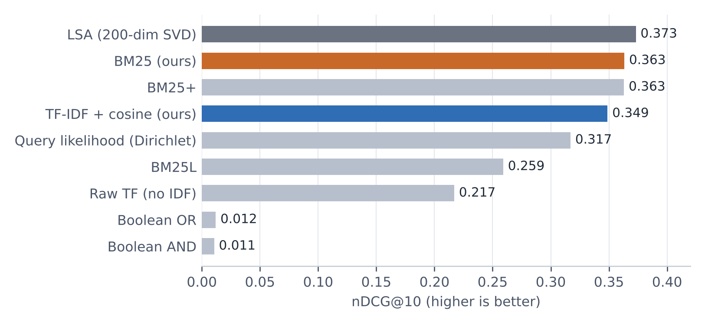
Figure 3: nDCG@10 of each ranker on Cranfield. Orange: the project’s BM25; blue: the project’s TF-IDF.
4.1 TF-IDF versus BM25
BM25 outperforms TF-IDF on every quality metric: nDCG@10 0.363 against 0.349 (+4.1 %), P@10 +3.9 %, MAP +2.7 % and MRR@10 +3.9 %, with recall at 100 essentially equal. It is also 1.5× faster per query, because it scores only documents in the posting lists of the query terms. Per query, BM25 achieves a higher nDCG@10 on 105 queries, TF-IDF on 77, and 43 are ties. A paired t-test on per-query nDCG@10 gives p ≈ 0.06 (a randomisation test gives the same), so the advantage on Cranfield is consistent but modest. This is expected: Cranfield abstracts have similar lengths, so the length bias that BM25 corrects is small here.
Among the other rankers, query likelihood (0.317) and BM25L (0.259) trail BM25, BM25+ ties it, and raw term frequency without IDF (0.217) shows how much the rarity weighting contributes. Boolean retrieval scores close to zero: long natural-language queries almost never match all their words (AND), and OR returns matches in no meaningful order. LSA is the only method slightly ahead of BM25 (0.373). Cranfield is small and technical, so mapping related terms to shared topics helps. LSA, however, requires an SVD of the full term–document matrix, which for Enron is 251,115 × 631,253, and it was the slowest ranker per query.
4.2 Sensitivity to the BM25 parameters
Table 4. nDCG@10 of BM25 on Cranfield for different k₁ (rows) and b (columns). Project default: k₁ = 1.5, b = 0.75.
 | b = 0 | b = 0.25 | b = 0.5 | b = 0.75 | b = 1
k₁ = 0.5 | 0.323 | 0.335 | 0.343 | 0.348 | 0.348
k₁ = 0.9 | 0.331 | 0.350 | 0.351 | 0.358 | 0.358
k₁ = 1.2 | 0.334 | 0.354 | 0.356 | 0.360 | 0.359
k₁ = 1.5 | 0.337 | 0.355 | 0.361 | 0.363 | 0.360
k₁ = 2.0 | 0.338 | 0.356 | 0.365 | 0.370 | 0.360

Length normalisation gives the largest gain: with k₁ = 1.5, moving from b = 0 to b = 0.75 raises nDCG@10 from 0.337 to 0.363 (+7.8 %). The best cell (k₁ = 2.0, b = 0.75, 0.370) is only 1.8 % above the defaults, and every setting with k₁ between 0.9 and 2.0 and b ≥ 0.5 lies between 0.351 and 0.370. BM25 therefore works well without tuning data, which matters for Enron, where none exists.
4.3 Results on the Enron corpus
On the full Enron index the two rankers return exactly the same set of matching e-mails, so the whole difference lies in the order. Table 5 lists the top result for six queries. TF-IDF consistently places one- to ten-word e-mails first, an effect of cosine length normalisation, while BM25 places informative e-mails of 100–600 words that are about the topic. BM25 also answers in about 5 ms against 40 ms for TF-IDF.
Table 5. Top-ranked e-mail for real queries on the 251,115 Enron e-mails (judged by inspection).
Query | TF-IDF #1 | BM25 #1
stock options | “Options” · 9 words | “ENE Options” · 159 words
power outage | “Outage” · 4 words | “Planned Power Outage at 3WTC on Sunday”
natural gas price | “RE:” · 4 words | “Where will Natural Gas prices go next?”
sec investigation | (no subject) · 7 words | “SEC investigation of stock buying”
skilling resign | “Skilling’s office” · 1 word | “FW: WSJ Skilling Interview”
bankruptcy | (no subject) · 4 words | “Bankruptcy in California; Implications…”

4.4 Comparison with published neural retrievers
Neural methods were outside our compute budget, so we compare with published results. BEIR [5] evaluates retrievers trained on MS MARCO on 18 datasets from domains they never saw, which matches the Enron situation of having no in-domain labels. Figure 4 shows that most dense and learned-sparse retrievers score below BM25 on average; only document expansion (docT5query, +1.6 %), late interaction (ColBERT, +2.5 %) and cross-encoder re-ranking of BM25’s own candidates (+11 %) are ahead.
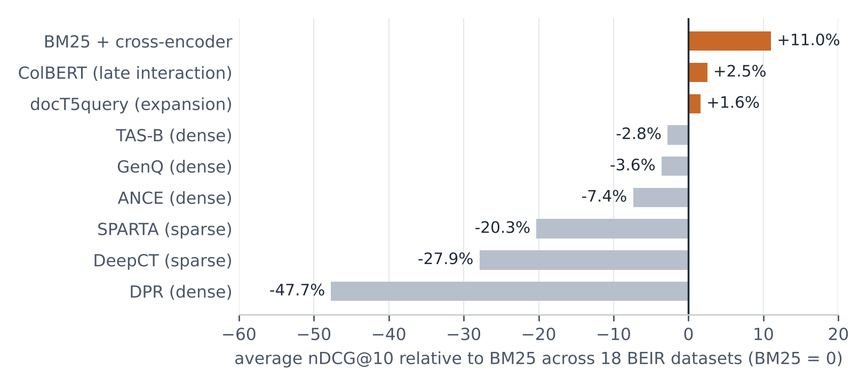
Figure 4: Average zero-shot nDCG@10 relative to BM25 across 18 BEIR datasets (data: Thakur et al. [5], Table 2).
Table 6. In-domain quality on MS MARCO passages [6] and cost per query on 1 M documents [5].
Model | MS MARCO MRR@10 | Query latency | Index size
BM25 | 0.187 | 20 ms (CPU) | 0.4 GB
Dense retrieval (DPR / TCT-ColBERT) | 0.335 (TCT-ColBERT) | 230 ms CPU · 19 ms GPU (DPR) | 3 GB (DPR)
ColBERT (late interaction) | – | 350 ms (GPU) | 20 GB
Hybrid TCT-ColBERT + BM25 | 0.353 | – | –
BM25 + BERT re-ranker | 0.372 (monoBERT) | 6.1 s CPU · 450 ms GPU | 0.4 GB

When trained on about 500,000 labelled MS MARCO queries, neural rankers almost double BM25’s MRR@10. That improvement depends on in-domain training data and GPUs, and comes with 10–300 times higher latency or 7–50 times larger indexes. The strongest systems, hybrid retrieval and re-ranking, also keep BM25 as a component. For a project with no relevance labels, a laptop CPU and a quarter of a million e-mails, BM25 offers the best balance of quality, speed, cost and explainability.
5. Conclusion
We built a search engine for 251,115 unique Enron e-mails and compared TF-IDF with cosine similarity and Okapi BM25 implemented from scratch. Sparse CSR/CSC matrices reduced a 1.27 TB term–document matrix to about 300 MB, the full index builds in about 75 seconds and loads in 1.3 seconds, and BM25 answers a query in about 5 ms.
On the Cranfield test collection, the project’s BM25 achieved the best nDCG@10 among the lexical and probabilistic rankers (0.363 against 0.349 for TF-IDF and 0.317 for query likelihood), won 105 of the 225 queries against TF-IDF’s 77, and was 1.5× faster. The parameter sweep showed that length normalisation contributes most of the gain and that the standard defaults are within 2 % of the best setting. On Enron, where lengths vary far more than in Cranfield, the difference is clearly visible: TF-IDF favours one- to ten-word replies, BM25 surfaces informative, on-topic messages. Published BEIR results confirm that BM25 remains a strong baseline that most neural retrievers do not beat without in-domain training.
The work has limitations. Both rankers are purely lexical, so a query for “layoffs” does not find “job cuts”. The system has no phrase search, typo tolerance or sender and date filters. Quality on Enron was judged by inspection because the corpus has no relevance labels, and the whole index must fit in memory. Future work includes hybrid retrieval that fuses BM25 with dense embeddings (for example with Reciprocal Rank Fusion [11]), BM25F to weight the subject above the body, labelling a set of Enron queries to compute nDCG on the target data, and moving to an on-disk engine such as Elasticsearch, which uses the same BM25 scoring, for larger collections.
References
1. Spärck Jones, K.: A statistical interpretation of term specificity and its application in retrieval. Journal of Documentation 28(1), 11–21 (1972)
2. Salton, G., Wong, A., Yang, C.S.: A vector space model for automatic indexing. Communications of the ACM 18(11), 613–620 (1975)
3. Robertson, S., Walker, S., Jones, S., Hancock-Beaulieu, M., Gatford, M.: Okapi at TREC-3. In: Proceedings of the Third Text REtrieval Conference (TREC-3), pp. 109–126 (1994)
4. Robertson, S., Zaragoza, H.: The Probabilistic Relevance Framework: BM25 and Beyond. Foundations and Trends in Information Retrieval 3(4), 333–389 (2009)
5. Thakur, N., Reimers, N., Rücklé, A., Srivastava, A., Gurevych, I.: BEIR: A Heterogeneous Benchmark for Zero-shot Evaluation of Information Retrieval Models. In: NeurIPS Datasets and Benchmarks Track (2021)
6. Lin, J., Ma, X., Lin, S.-C., Yang, J.-H., Pradeep, R., Nogueira, R.: Pyserini: A Python Toolkit for Reproducible Information Retrieval Research with Sparse and Dense Representations. In: Proceedings of SIGIR, pp. 2356–2362 (2021)
7. Ponte, J.M., Croft, W.B.: A language modeling approach to information retrieval. In: Proceedings of SIGIR, pp. 275–281 (1998)
8. Deerwester, S., Dumais, S.T., Furnas, G.W., Landauer, T.K., Harshman, R.: Indexing by latent semantic analysis. Journal of the American Society for Information Science 41(6), 391–407 (1990)
9. Cleverdon, C.W.: The Cranfield tests on index language devices. Aslib Proceedings 19(6), 173–194 (1967)
10. Klimt, B., Yang, Y.: The Enron Corpus: A New Dataset for Email Classification Research. In: Proceedings of ECML, pp. 217–226 (2004)
11. Cormack, G.V., Clarke, C.L.A., Buettcher, S.: Reciprocal Rank Fusion outperforms Condorcet and individual Rank Learning Methods. In: Proceedings of SIGIR, pp. 758–759 (2009)

